|  |
| --- |
| Name: Udugama Nuwanthika |
| Student Reference Number: 10749139 |



|  |  |
| --- | --- |
| Module Code: PUSL2023 | Module Name: Mobile App Development |
| Coursework Title: Project Proposal | |
| Deadline Date:30th of March 2022 | Member of staff responsible for coursework:  Mr. Iman Ashly |
| Programme: BSc (Hons) Software Engineering | |
| Please note that University Academic Regulations are available under Rules and Regulations on the University website [www.plymouth.ac.uk/studenthandbook](http://www.plymouth.ac.uk/studenthandbook). | |
| Group work: please list all names of all participants formally associated with this work and state whether the work was undertaken alone or as part of a team. Please note you may be required to identify individual responsibility for component parts.  Udugama Nuwanthika 10749139  Rajapaksha Rajapaksha 10749121  Merenna Amarasinghe 10749150  Sakaladhipathige Fernando 10749110  Bopage Muthumala 10749145  Randeera Withanage 10749185  ***We confirm that we have read and understood the Plymouth University regulations relating to Assessment Offences and that we are aware of the possible penalties for any breach of these regulations. We confirm that this is the independent work of the group.***  A black and white photo of a handwritten note  Description automatically generated with low confidence  Signed on behalf of the group: | |
| Individual assignment: ***I confirm that I have read and understood the Plymouth University regulations relating to Assessment Offences and that I am aware of the possible penalties for any breach of these regulations. I confirm that this is my own independent work.***  Signed: | |
| Use of translation software: failure to declare that translation software or a similar writing aid has been used will be treated as an assessment offence.  I *have used/not used translation software.  If used, please state name of software………………………………………………………………… | |
| **Overall mark _____% Assessors Initials ______ Date_________** | |

*Please delete as appropriateSci/ps/d:/students/cwkfrontcover/2013/14

***Head-Up Display***

***Widgets***

***Project Proposal***

PUSL 2023 Mobile Application Development

Group No.53

**Introduction**

The Head-Up Display (HUD) is a technology that projects an essential information about directly the driver's line of sight onto the vehicle's windscreen without restricting it. The driver's concentration remains on the road ahead, which not only improves safety but also reduces eye fatigue by decreasing the need to move focus between the road and the instruments. Because of that they don’t have to struggle looking for information inside the car and Eyes tend to re-focus faster on the road when you take your eyes off the HUD. To achieve this, we use android device to projects a transparent image on to the windscreen. Driver can see the compass, vehicle speed, pitching of the vehicle, rolling of the vehicle, live location of the vehicle and trip info. Drivers will get all the information that you need while driving at single place.

**Features**

Using this HUD Widgets mobile application users can mainly check information of their vehicle. There are 6 types of widgets,

* Speedometer
* Rolling
* Pitching
* Compass
* Live Location Tracking
* Trip Info

**Requirements**

Functional Requirements

* Check the Speed

To display the accurate speed of the vehicle, at least vehicle speed should have 4kmph speed.

* Check the Rolling

By using the android device acetometer sensor, we get Y axis value and decide the rolling of the vehicle.

* Check the Pitching

We get X axis value by using android device acetometer sensor, we decide the pitching of the vehicle.

* Compass

By using the magnetic sensor of the android device, we display all the 8 directions.

* Live Location Tracking

We use Google Maps API (Night Mode) for live location tracking.

* Check Trip Info

In here, users can click the ‘’Start’’ button in the beginning of a new journey and click the ‘’End’’ button in the end of the journey. After the end of the journey, user can see the mileage, max speed, average speed, and the duration of the journey.

Non – Functional Requirements

* Performance

The system should perform fast and respond to user interactions within less time. The accuracy of the location might change depending on the GPS signal strength. Since we’ll be using an android device, the accuracy of the directions depends on the compass.

Android version should be 7.0 or higher.

* Usability

The user should be able to easily understand how to use the app. So, the UI design should be simple to avoid any confusion. Therefore, we use green, red, white, and black as colors. We will be using black as our mobile app background color.

* Scalability

Since we’re developing this app for the vehicles, we can assume that the scale won’t change much over time. So, we can identify the required resources and performance quantity wise from the beginning.

**Prototype User Interfaces**



***Splash Screen***

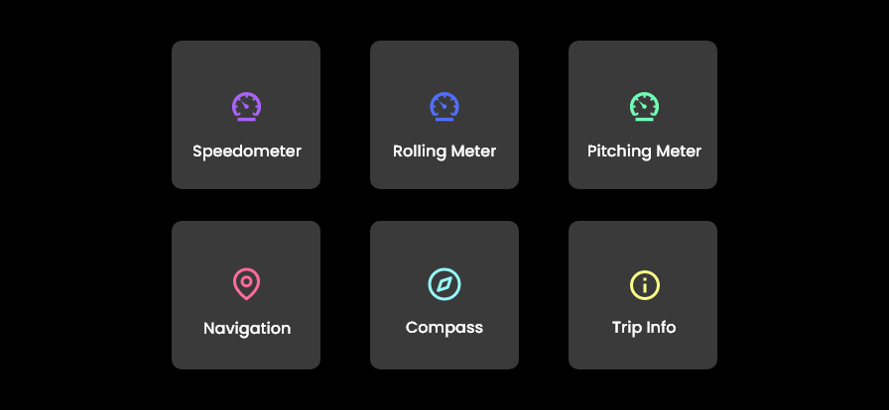

***Home Screen***



***Speedometer***

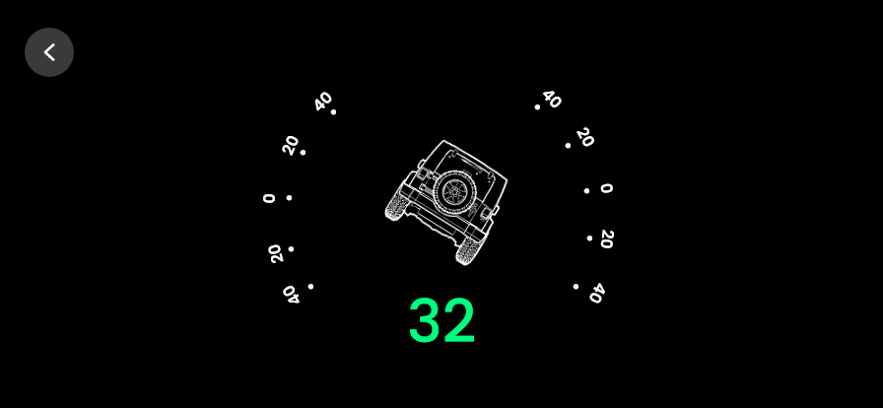

***Rolling***

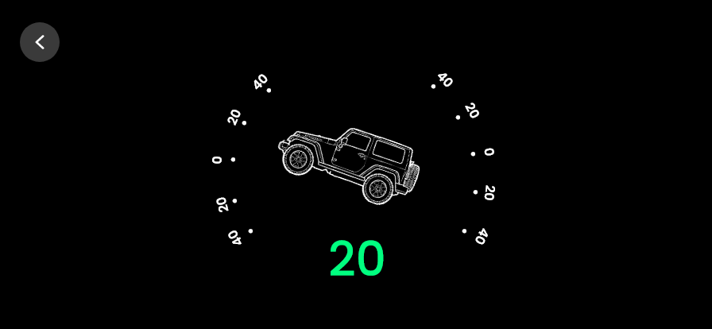

***Pitching***

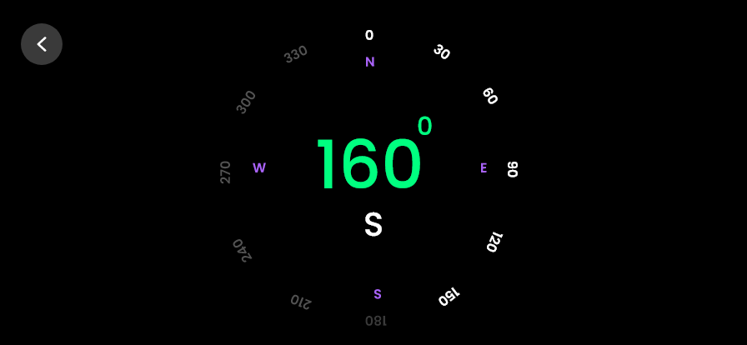

**Compass**

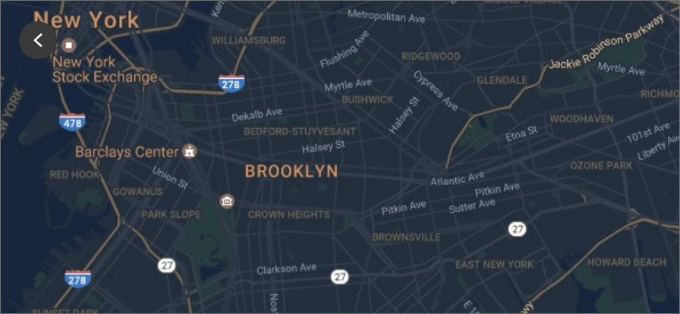

***Live Location***

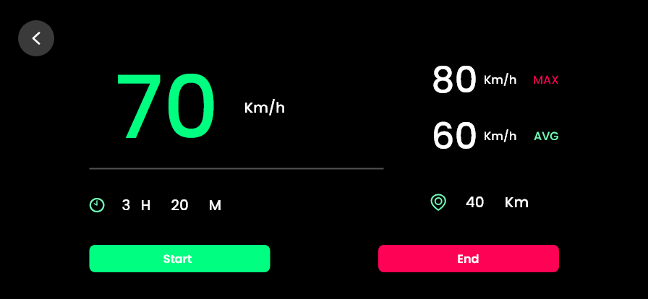

***Trip Info***

**Mock-ups**

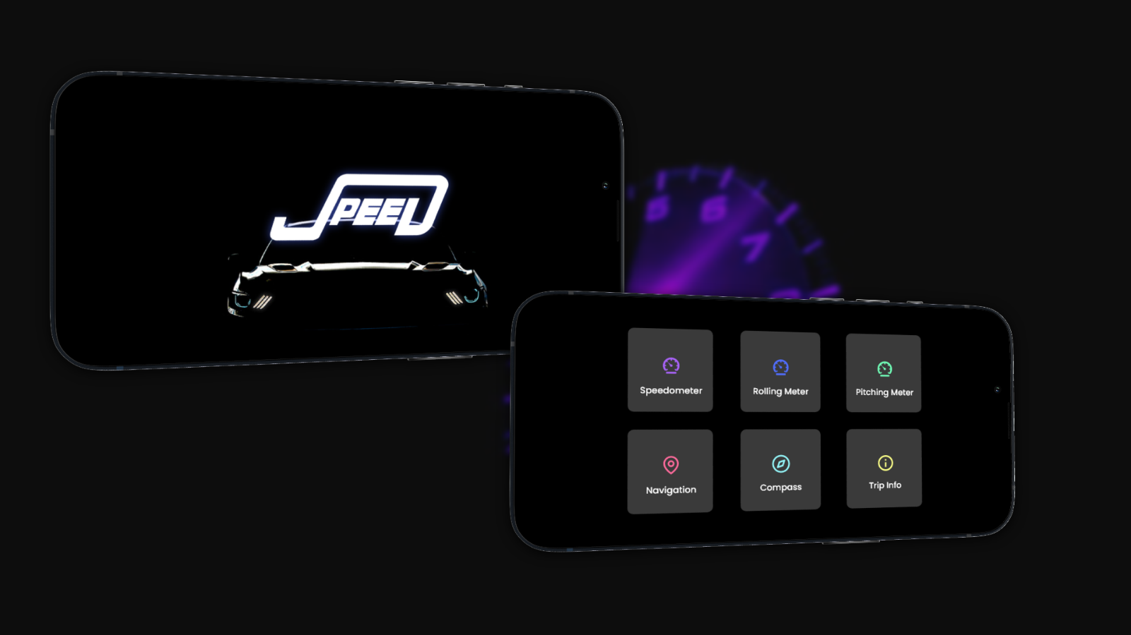

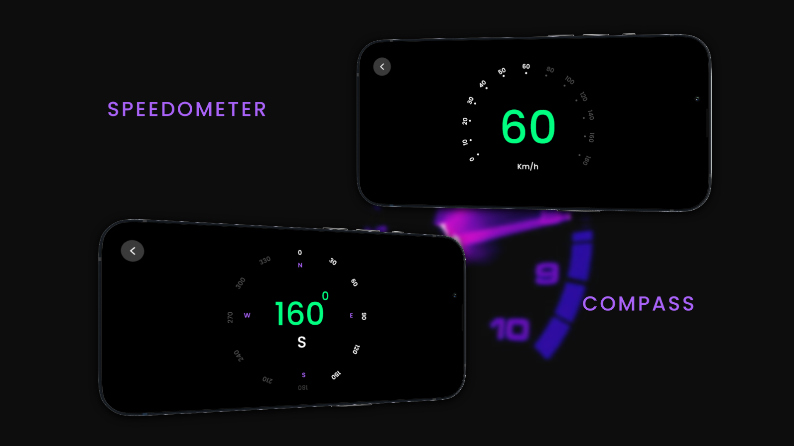

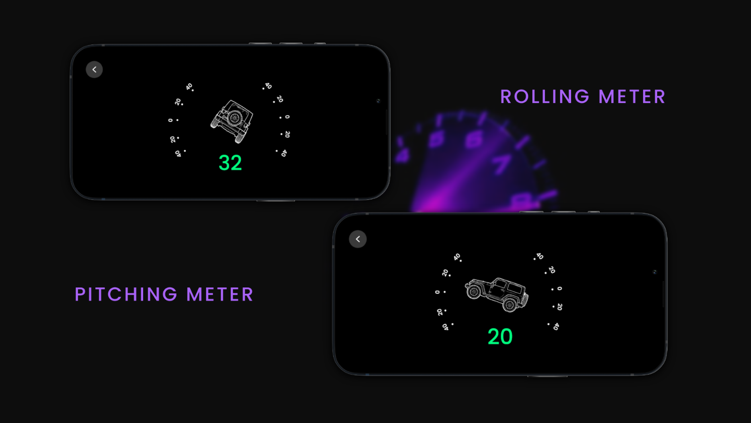

**Group Details**

|  |  |  |
| --- | --- | --- |
| Plymouth ID | Name | Email |
| 10749139 | Udugama Nuwanthika | [10749139@students.plymouth.ac.uk](mailto:10749139@students.plymouth.ac.uk) |
| 10749121 | Rajapaksha Rajapaksha | [10749121@students.plymouth.ac.uk](mailto:10749121@students.plymouth.ac.uk) |
| 10749150 | Merenna Amarasinghe | [10749150@students.plymouth.ac.uk](mailto:10749150@students.plymouth.ac.uk) |
| 10749110 | Sakaladhipathige Fernando | [10749110@students.plymouth.ac.uk](mailto:10749110@students.plymouth.ac.uk) |
| 10749145 | Bopage Muthumala | [10749145@students.plymouth.ac.uk](mailto:10749145@students.plymouth.ac.uk) |
| 10749185 | Randeera Withanage | [10749185@students.plymouth.ac.uk](mailto:10749185@students.plymouth.ac.uk) |